ESP32 - TFT LCD

TFT Pin | ESP32-S3 Pin | Purpose
VCC | 5V | Power
GND | GND | Ground
CS | GPIO14 | Chip Select
RESET | GPIO13 | Reset
DC | GPIO12 | Data/Command
MOSI | GPIO11 | SPI MOSI
SCK | GPIO10 | SPI Clock
LED | 3.3 V | Backlight
MISO | GPIO9 | SPI MISO

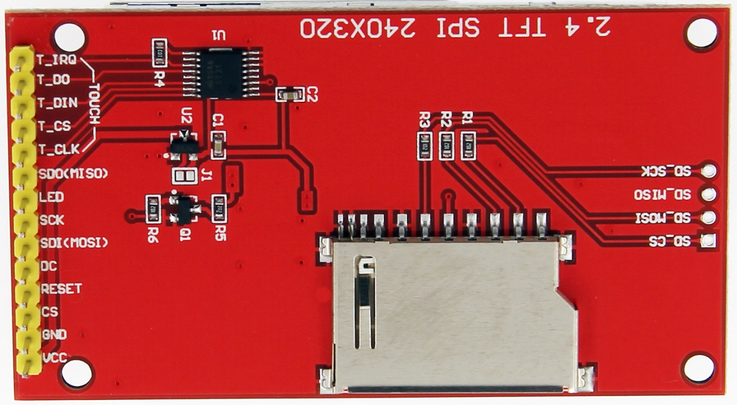

Keypad 4×3
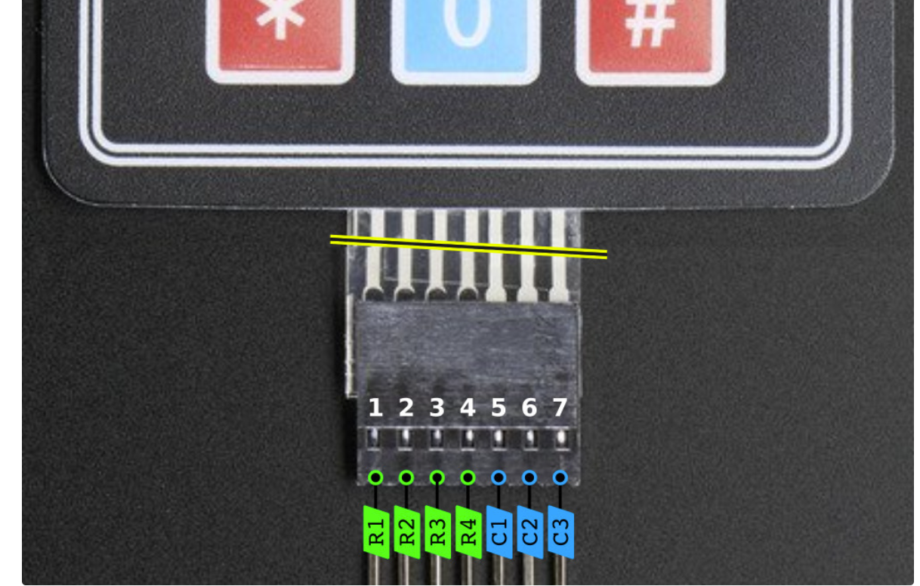
C3 → GPIO5
C2 → GPIO6
C1 → GPIO7
R4 → GPIO15
R3 → GPIO16
R2 → GPIO17
R1 → GPIO18

Ultrasonic
VCC → 3.3 V
GND → GND
Trig → GPIO 3
Echo → GPIO 46

Buzzer

BUZZER “+” → 3V3
BUZZER “–” → NPN collector (e.g., 2N2222, S8050, BC547)
NPN emitter → GND
ESP32 GPIO4 → 10 kΩ → NPN base
100 kΩ from base to GND (optional pull-down)
1 kΩ resistor in parallel with the buzzer (“+” to “–”) as the sheet suggests for charging/discharging the piezo.
Common GND between ESP32 and the transistor side.

Temp & Humid

BME280 Pin | ESP32-3Pin | Function
VIN | 3V3 | Power
GND | GND | Ground
SCK | GPIO42 | I²C Clock (SCL)
SDI | GPIO41 | I²C Data (SDA)

Accelerometer

MPU6050 | ESP32-S3 Pin
VCC | 5 V
GND | GND
SCL | GPIO 2
SDA | GPIO 1

